**PYTHON ASSIGNMENT**

* **Get list**

lst = []

n = int(input("Enter number of elements : "))

for i in range(0, n):

ele = int(input())

lst.append(ele)

print(lst)

* **Insert list and print list**

lst.insert(3,10)

print(lst)

* **Remove first occurence**

lst.remove(lst[0])

print(lst)

* **Insert at end of list**

lst.append(13)

print(lst)

* **Sort the list**

lst.sort()

print(lst)

* **Remove the last element of list**

lst.pop()

print(lst)

* **Reverse the list**

lst.reverse()

print(lst)

**OUTPUT**

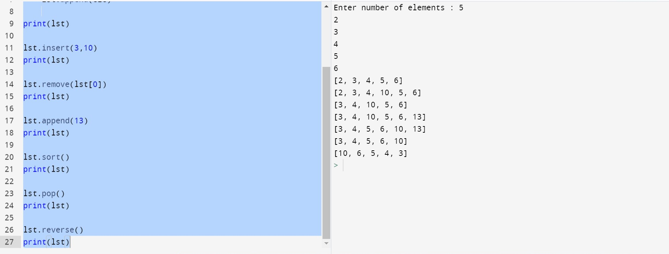

**Program make a simple calculator**

def add(x, y):

return x + y

def subtract(x, y):

return x - y

def multiply(x, y):

return x * y

def divide(x, y):

return x / y

print("Select operation.")

print("1.Add")

print("2.Subtract")

print("3.Multiply")

print("4.Divide")

while True:

choice = input("Enter choice(1/2/3/4): ")

if choice in ('1', '2', '3', '4'):

num1 = float(input("Enter first number: "))

num2 = float(input("Enter second number: "))

if choice == '1':

print(num1, "+", num2, "=", add(num1, num2))

elif choice == '2':

print(num1, "-", num2, "=", subtract(num1, num2))

elif choice == '3':

print(num1, "*", num2, "=", multiply(num1, num2))

elif choice == '4':

print(num1, "/", num2, "=", divide(num1, num2))

next_calculation = input("Let's do next calculation? (yes/no): ")

if next_calculation == "no":

break

else:

print("Invalid Input")

**Why python is popular programming language?**

* Simple syntax
* Easy to use
* Faster execution
* Greater Efficiency
* Scalability

**What are the other Frameworks that can be used with Python?**

* Django
* Falcon
* Flask
* Dash
* Cherrypy
* Cubicweb
* Bottle

**Full form of WSGI**

WSGI - Web Server Gateway Interface